**Unit 1 Industrial expectations at the workplace**

* 1. **SWOT ANALYSIS**

Ask yourself these questions to determine your internal and external factors such as:

1.strengths

• What am I enjoying doing?

• What are my unique skills?

• What are the skills that I have but others don’t have?

• What do others see as my strengths?

2. Weakness

* What stops me from achieving my goal?
* What do I need to improve to achieve my goal?
* In which area do I need more attention and skill-based learning?
* What are my negative traits/habits?

3. Opportunities

* How can my network help me with my future career?
* How can my skills fill the need in the industry that I want to work in?
* Is there any significant change in the industry that I can take advantage of
* What opportunities are open to me?

4. Threats

* Is my personality hurting my career path?
* Are there any skills that my competitors have that I don’t have?
* Are any of my strengths holding me back?
* What demotivates me and scares me?

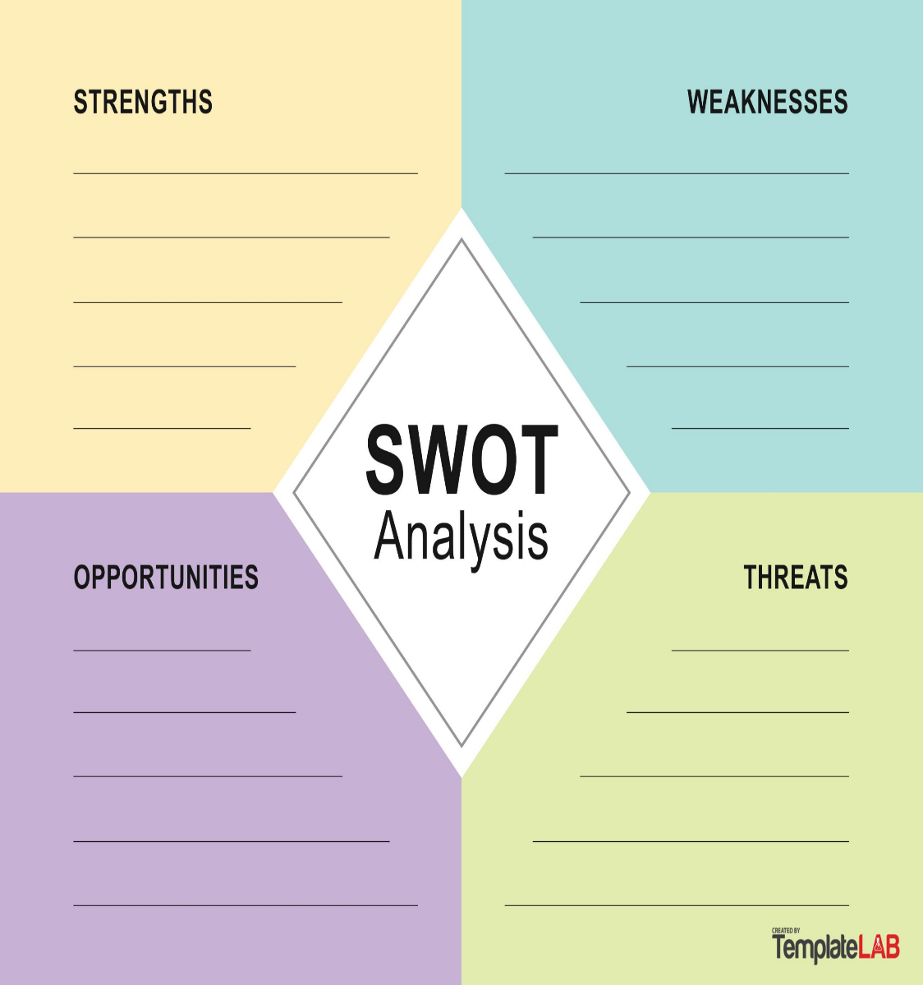

1.2.**UNIQUE SELLING PROPOSITION**

You may need to adjust your pitch based on the job profile. Here is an example: Because of my _______, I can do _______ for you better than typical applicants."

1. Identify your USP; what you are good at inside and outside work, what you have learned inside the university and outside, what are the internships, projects, and other relevant experiences that you worked on

2. Tailor your USP; cross-reference all your skills and expertise against all of the requirements outlined in the job description. If any matches then mention them in your cover letter and cv. Portray yourself as someone who will fit in.

3. Focus on the benefits that you can offer the company if they hire you. Eg ; Instead of claiming ‘I can do X, Y, and Z’ you should focus on what that means for the employer; ‘I can do X, Y, and Z which means that I’ll save you time, money, and effort’.

**1.3.CREATING AN EFFECTIVE ELEVATOR PITCH**

One effective way to think about your elevator pitch for a job interview is to ensure it covers these basics:

Your name

Mapping of skills with JD

Projects and internships

Certifications

USP

Your specialty and industry

Your experience, in years

Your goal

Call to action

ELEMENTS OF CURRICULUM VITAE

Resumes tell the employer about your experiences, skills, and work history. Use your resume to highlight items that indicate you are a good worker, are qualified for the position, and bring desirable skills to the job. If you are a student and have little or no previous job experience, enhance information about your school and community activities.

Personal Information

Name Current and Permanent address (may be omitted from a resume posted on the web)

Telephone number ( add the country code)

E-mail address

Education-High school name-City and State-Date of graduation ( In reverse chronological order)

Course Highlights (courses directly related to the job or your career field and special abilities)

Work Experience / Internship / Training /Projects

List your most recent position first, continuing in reverse chronological order including the name, location, and dates of your employment/internship for each company you have worked for. Aim to use bullet points wherever possible to highlight your responsibilities and achievements in each role so the person scanning your CV can quickly match up your experience with their job description. Start with an action word such as: worked, learned, advertised, understood, assessed, analyzed, contributed, etc.

Certifications /Responsibilities/Awards/ Achievements/ honours/Scholarships/Grants/

**1.5.2 RESUME SHOULD BE:**

**• Specific rather than general**

**• active rather than passive**

**• Written to express not impress**

**• Be consistent in format and content**

**• easy to read and follow, balancing white space**

**• done inconsistent spacing, bold, and capitalization for emphasis**

**• with headings (such as Experience) in order of importance**

**• in proper format when converted to .pdf**

**• In passive language**

**• without Spelling and grammar errors**

**• Using personal pronouns (such as I)**

**Note: linkedIn checklist attached along with handout**